MILITAR, MARCUS G. ECE2112

2ECE – C PROGRAMMING ASSIGNMENT

EXPERIMENT 7

PROBLEM 1

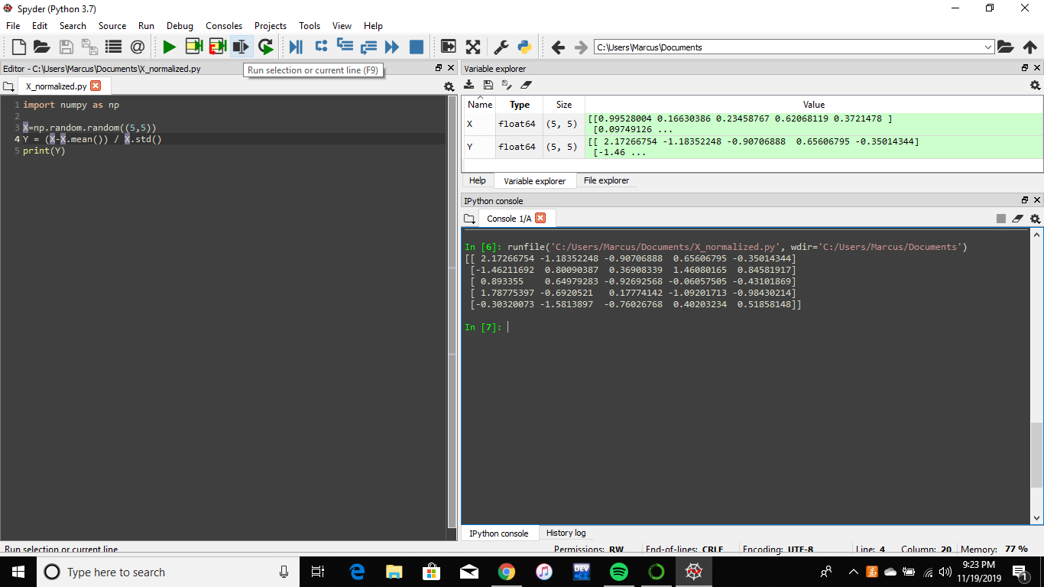

PROBLEM 2

